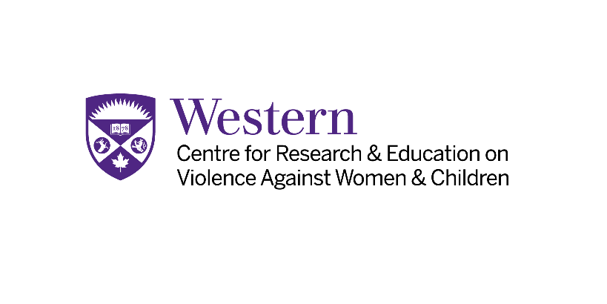

Centre for Research & Education
on Violence Against Women & Children Student Awards

Application Cover Page

Student information:
Name:
Western Student Number:
Faculty:
Department/Program:
Home Address:
Email:
Phone:
Award(s) you are applying for:
Elisabeth Steel Reurink Memorial Award  (Applications due October 15, 2025) | Scotiabank Graduate Award for Studies in Violence Against Women and Children  (Applications due October 15, 2025) | Scotiabank Undergraduate Award for Studies in Violence against Women and Children  (Applications due October 15, 2025)

Letter(s) of support:
(Applications can include up to 3 letters of support – 2 from academic leaders and 1 from a community member)
Name:
Title:
Email: Phone:

Name:
Title
Email: Phone:
Name:
Title
Email: Phone:

Submit to:

Applications must be emailed as one PDF file to crevawc@uwo.ca. Nominations will be adjudicated by an awards committee comprising members from the Centre for Research & Education on Violence Against Women & Children.
Applications must contain:
- Completed cover page
- Personal letter (1 page)
- Letter of support from an academic leader (teacher, professor, counsellor) (max. 2)
- Letter of support from a community member (max. 1)
- Short CV (four pages)

